In this used data.sql in resource folder for inserting the data in table as soon as its get created in my -sql database .

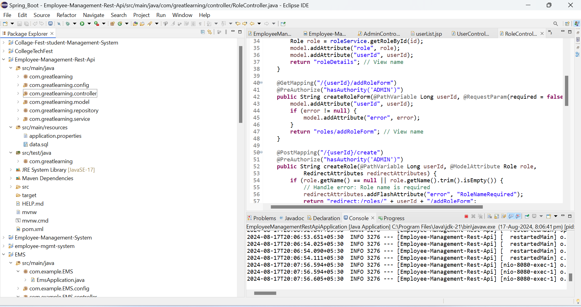

Data.sql insert primary value available for table entity employees,users,roles,user-roles tables as follow.

There is two user 1. username-admin, password-admin123

2. username-user, password-user123

There is Two Role define and inserted in roles table initially as ADMIN having all authority and USER having limited authority only view.

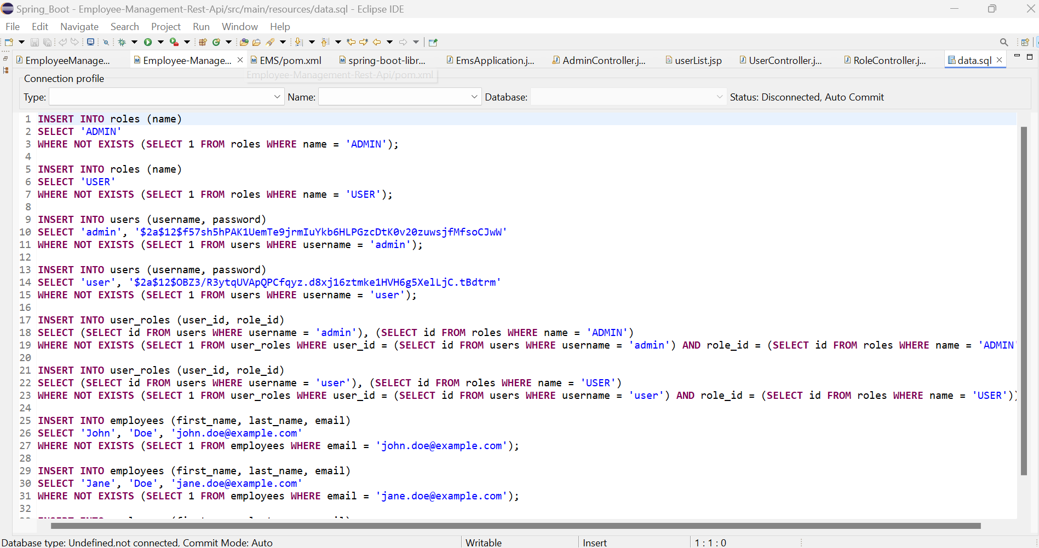

After login with admin user with username-admin, password-admin123 direct to below page

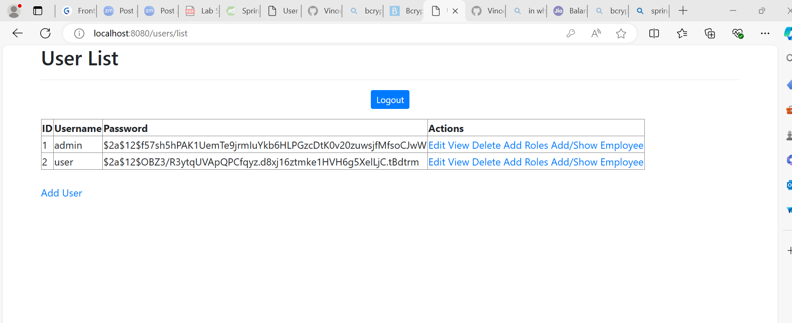

Admin user have authority to do all the action mentioned in Action tab plus can add new user.

Question-1. Application should be able to add roles in the database dynamically in the db

a.To test restapi in postman we require to login first in postman with admin credential to get the session cookies

b.Follow this step in postman to test api for role creation

* Create new collection and go to authorization and set from drop down basic auth and username password as below

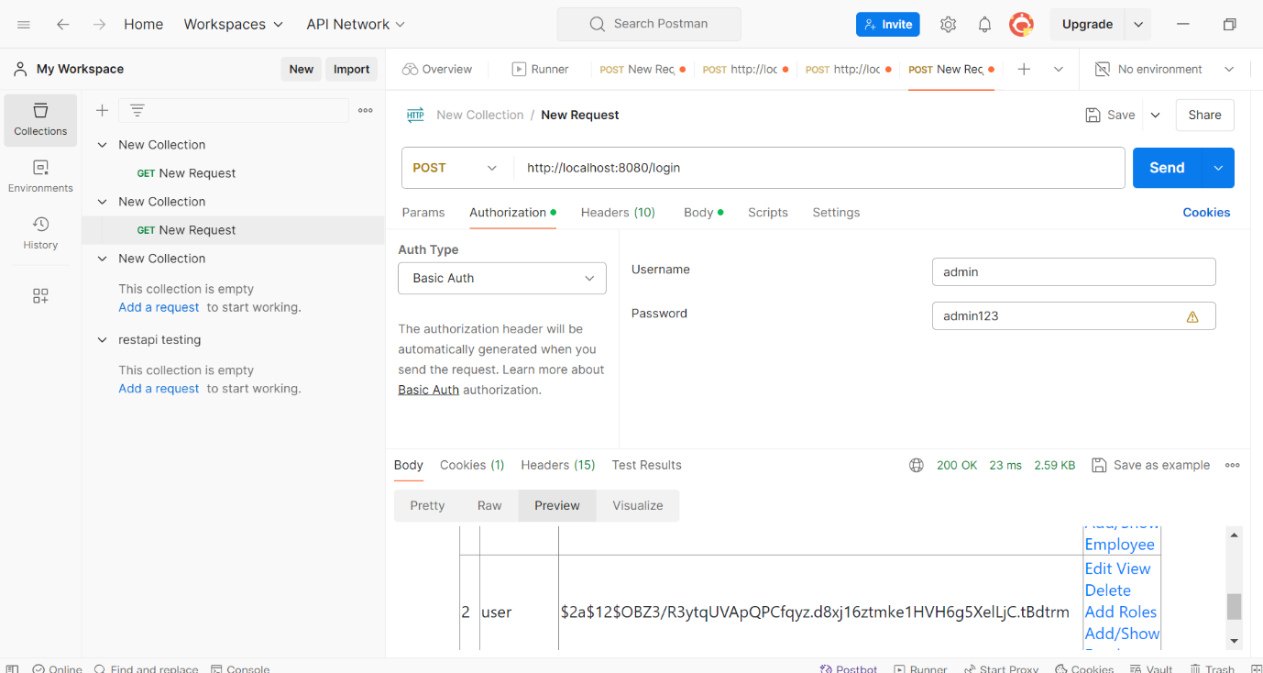

* Now go to body tab and do following setting with key-value pair for username and password

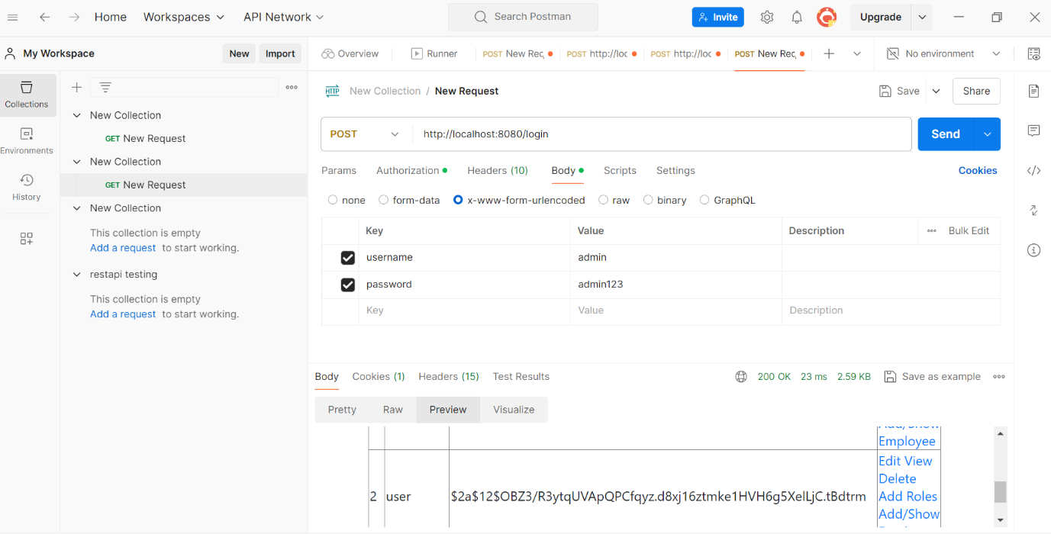

* Type url in as <http://localhost:8080/login> method as post and click on send you will get userlist in response body

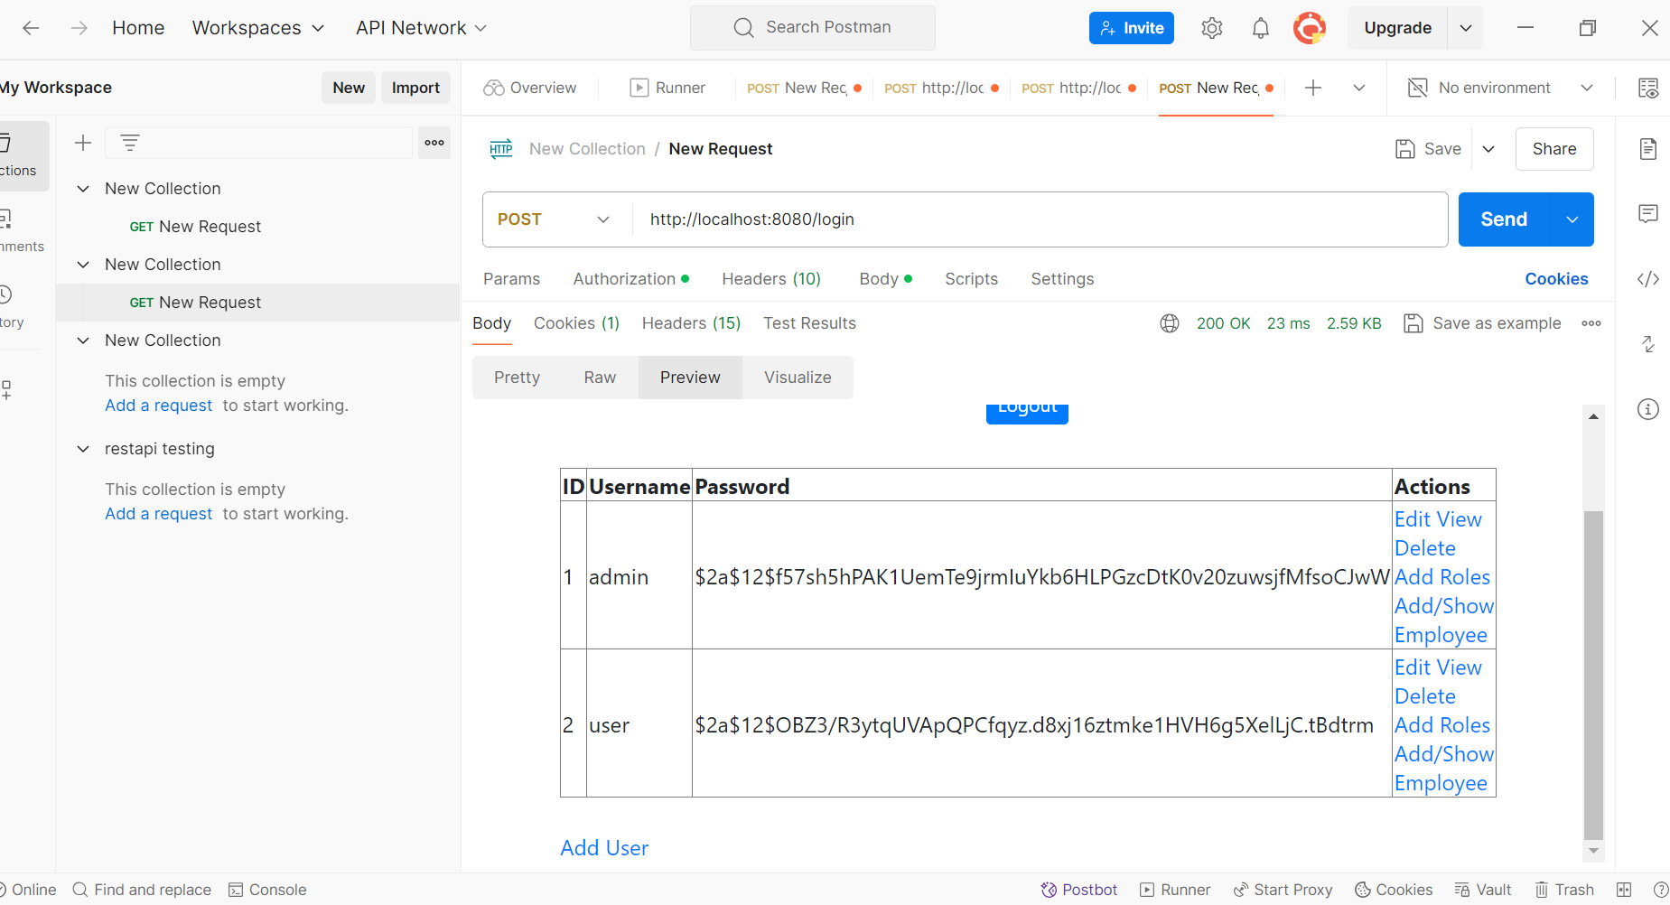

* Now to add role with rest api type url- http://localhost:8080/api/roles/3/createRole mentioned in rolerestcontroller and in body tab select as raw Jason and type new role in json body click send as below

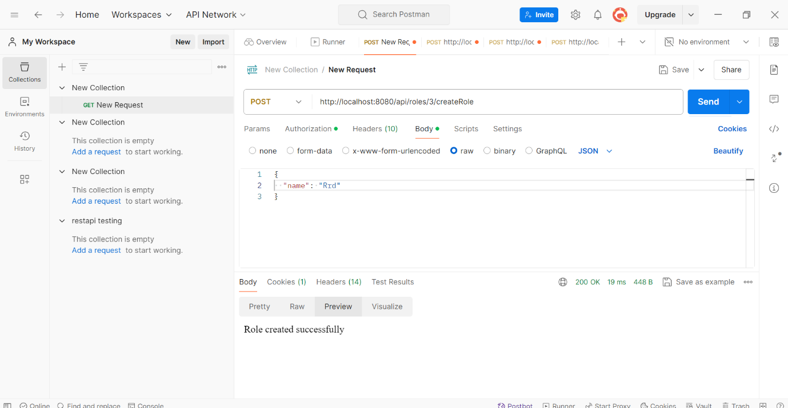

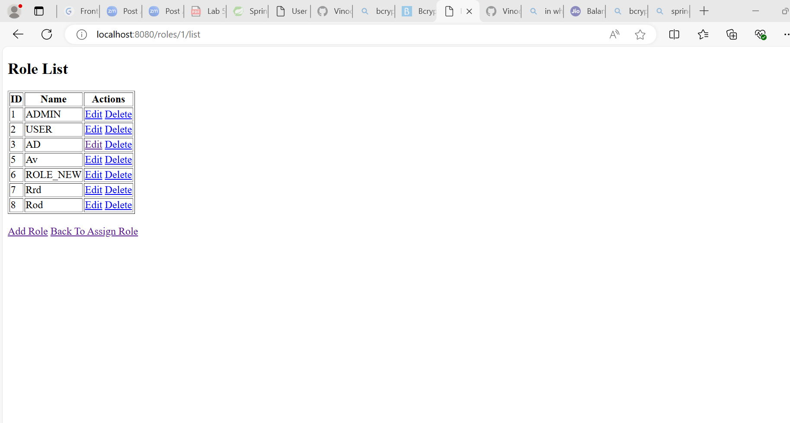

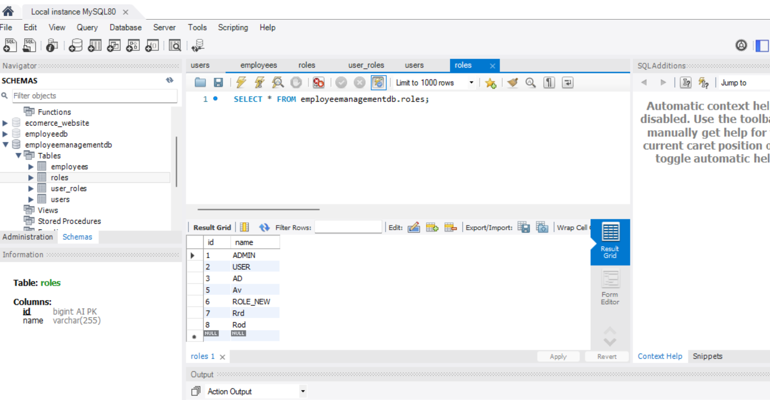

* Note:verify url properly otherwise get this error

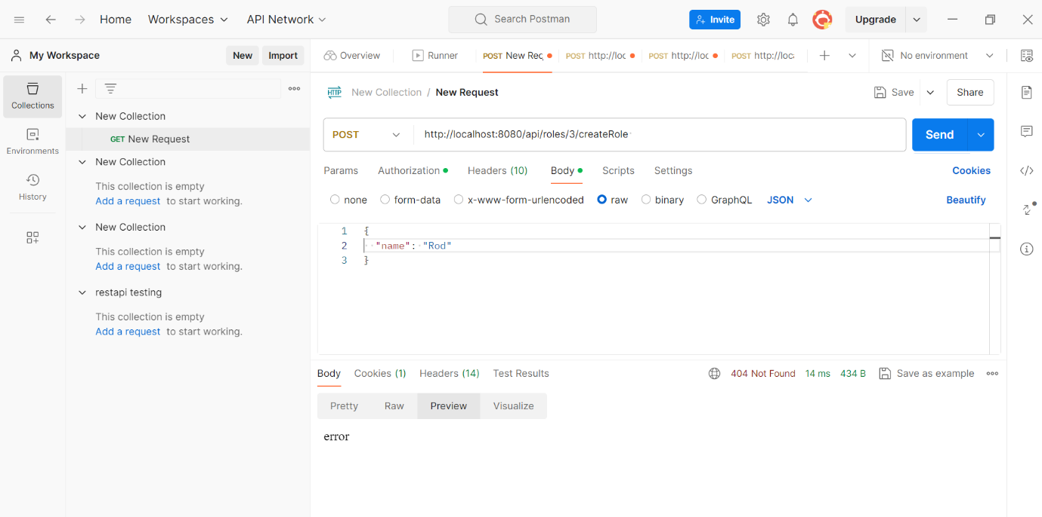

* We can also add role through ui in browser url- <http://localhost:8080/roles/1/addRoleForm> as below

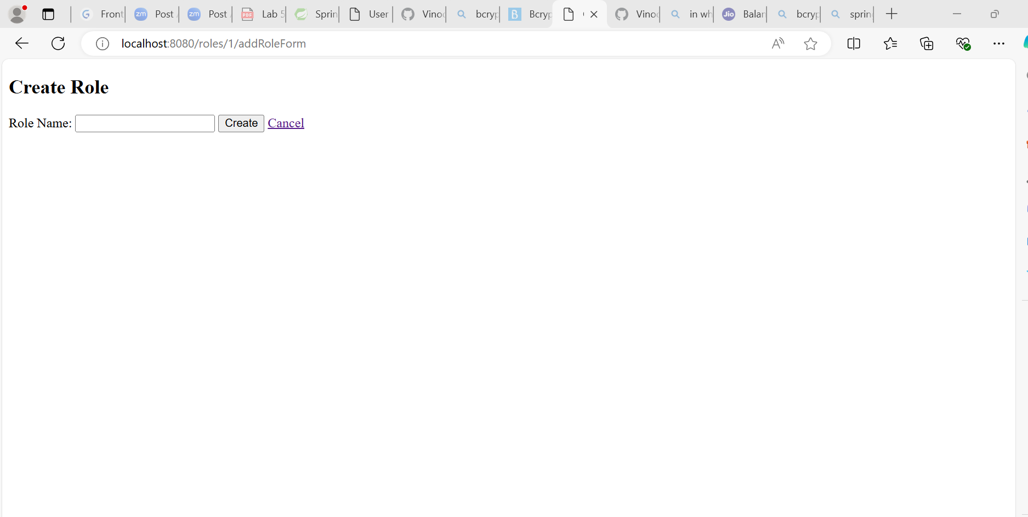

* Add role through ui by clicking on add role as below

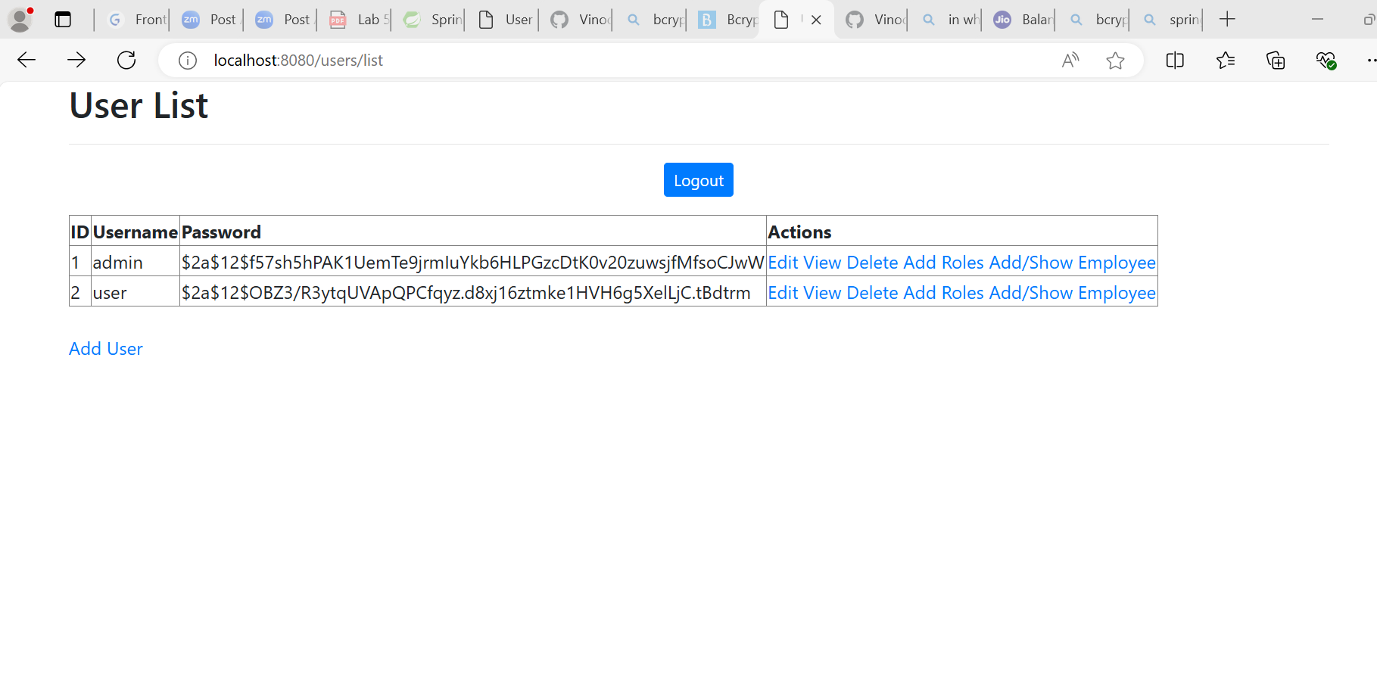

* Will take you add role to user as below clock on creat role

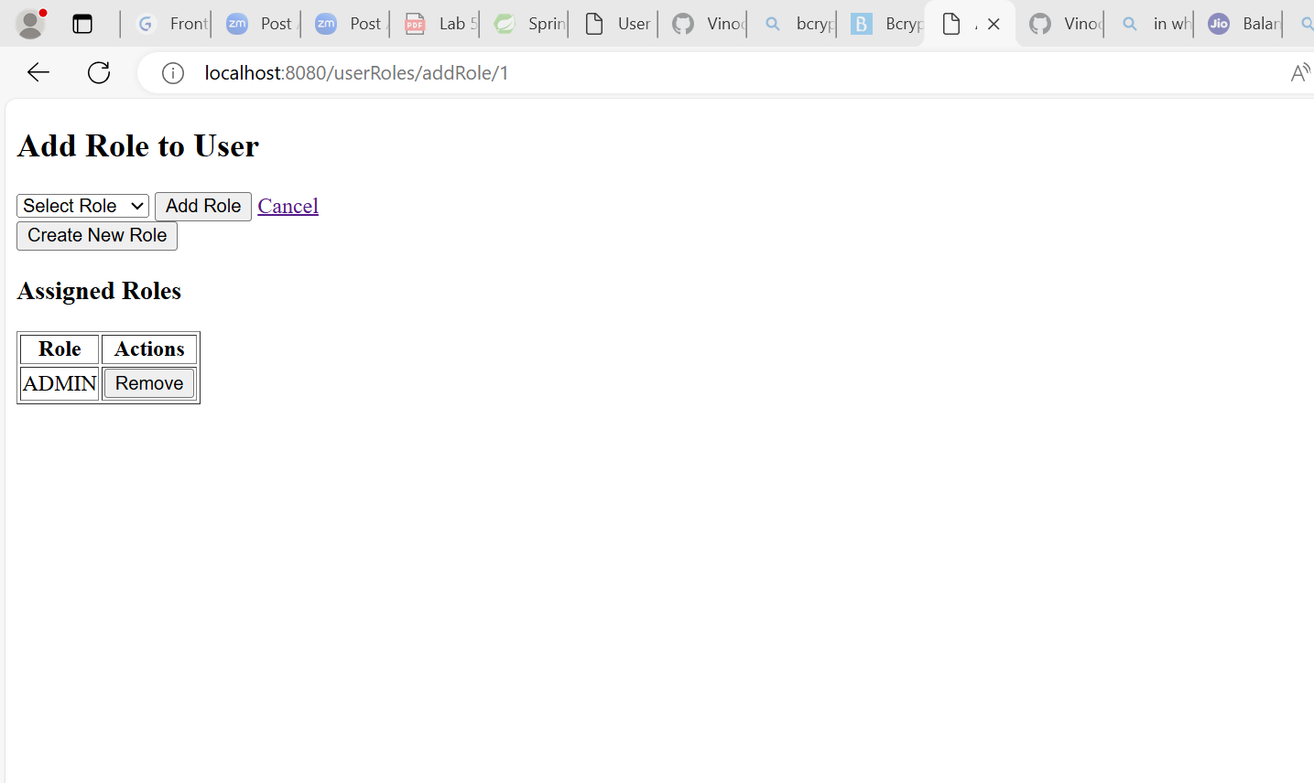

* Will take you role list then click on add role as below

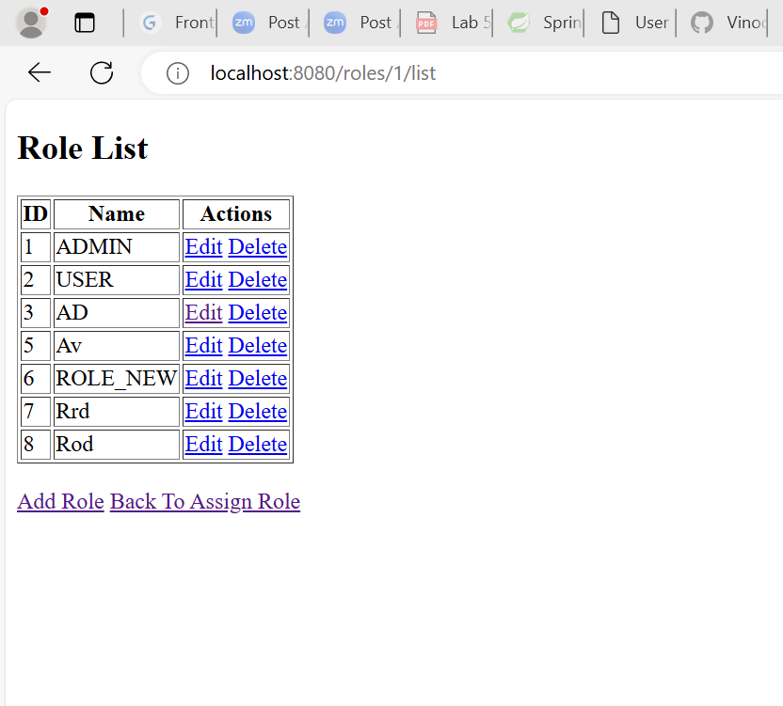

* Will take you to addroleform as below and create new role there by entering the role and clicking on create

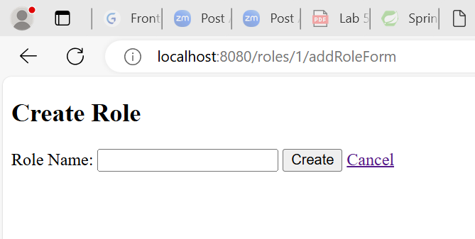

Question-2. application should be able to add Users in the db which can be used for authentication purposes.

* To create user with rest api through postman follow the login step with postman describe above for creating role if login already in postman directly test url



* If you are seeing user list like above means you are login with admin credential and good to go for creating user otherwise follow step above to login first
* Now to add user with rest api type url- <http://localhost:8080/api/users/create> mentioned in RestUserController and in body tab select as raw Jason and type new user body in json body click send as below

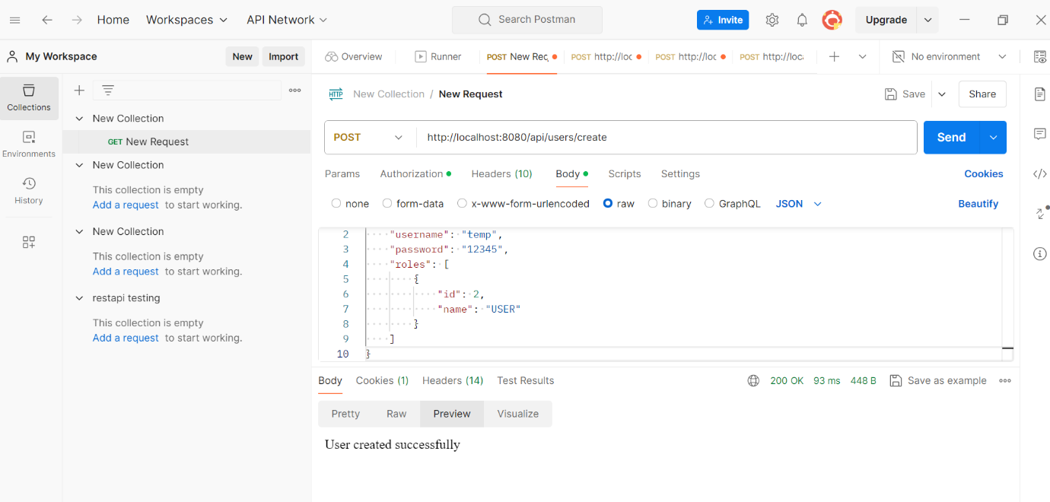

* You will get User created successfully in response body like above if everything is correct and you can verify creted user in db with role assign as below

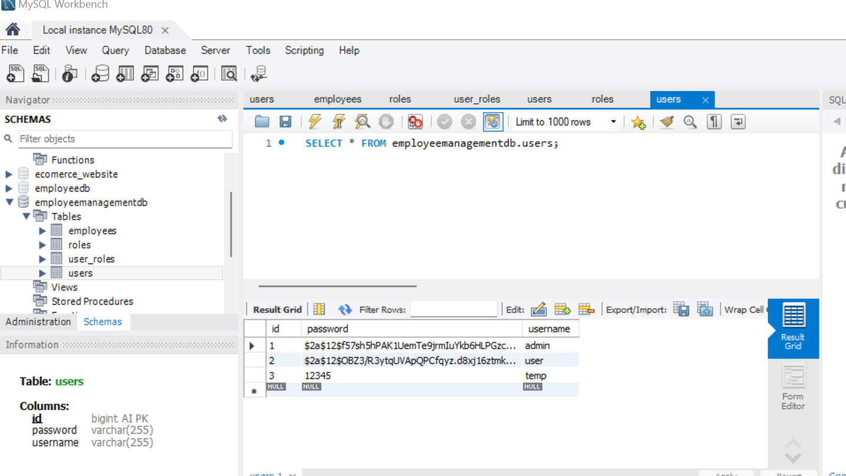

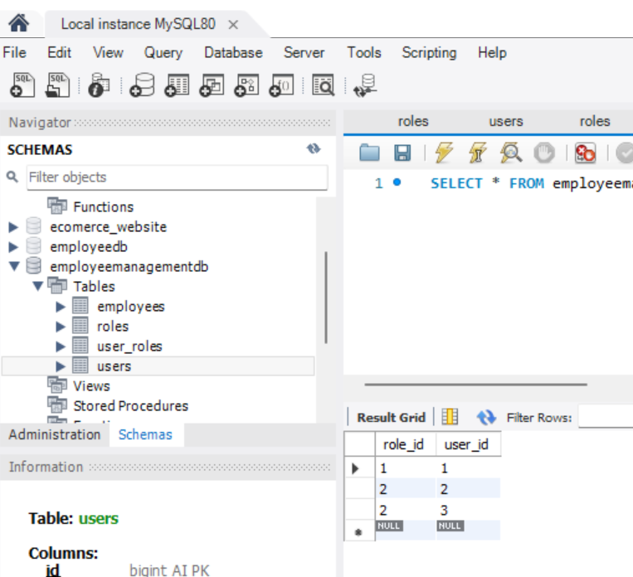

* Same thing can be done through UI by clicking on add user as below in browser

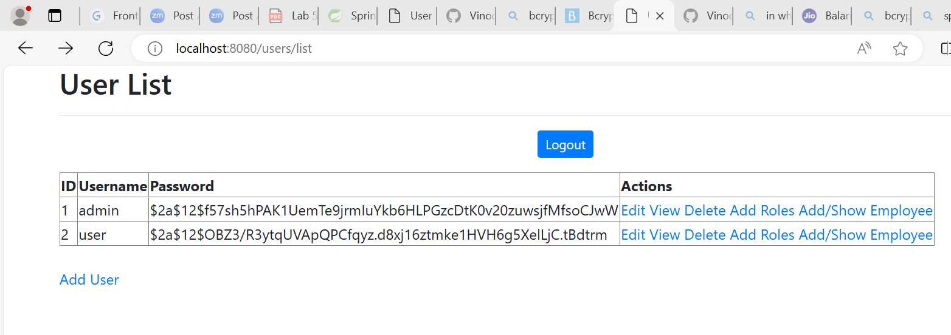

* It will direct to adduserform as below were enter the user name and password as below and click on submit

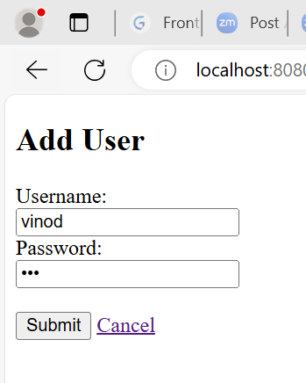

* User will be created and it will direct you to user list as below with new created user

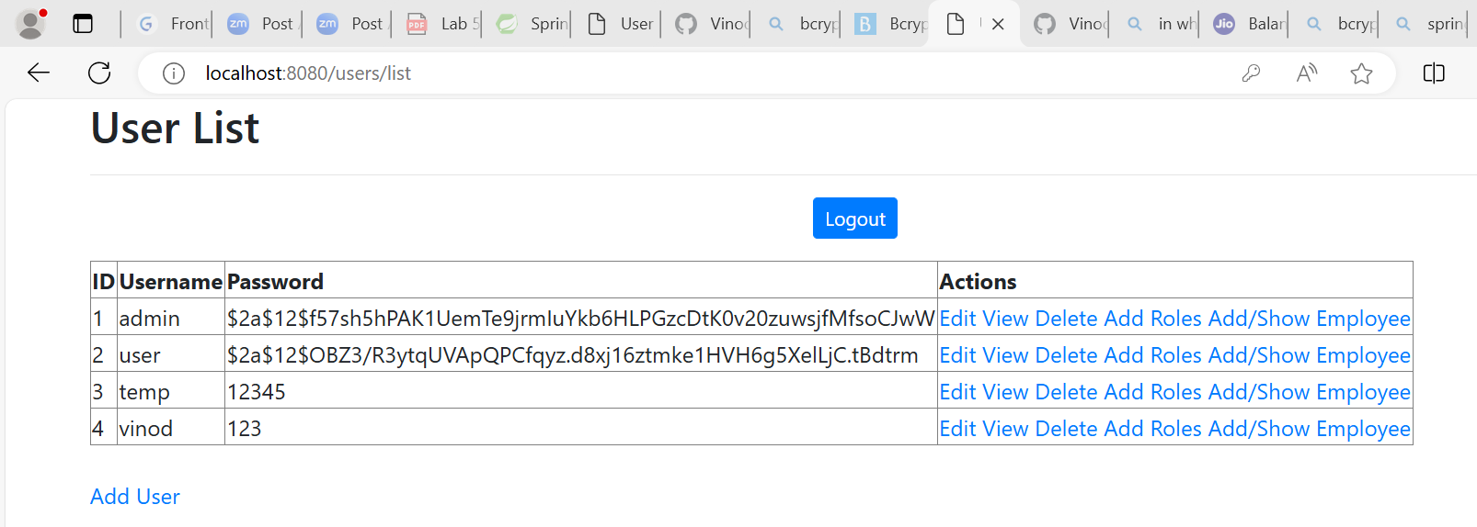

* Now you can assign role to created user by clicking on add role in action column and it will direct you to below page were select the role from drop down list as below an click on add role button next to it to create role for the created user as below.

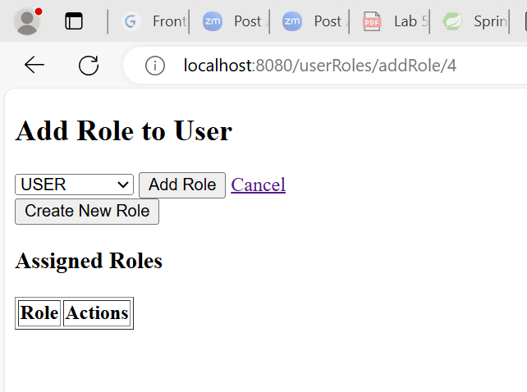

* After clicking on add role the assign role will reflect there as below that can be verify through db also.

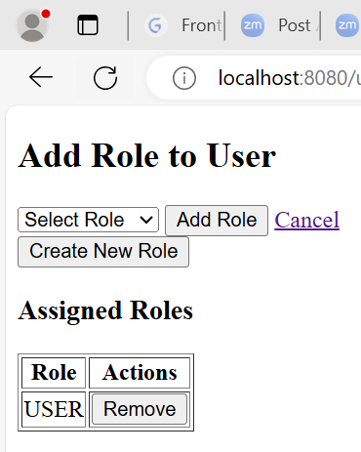

QUESTION-3. Now Your application should be able to add employees data in the db if and only if the authenticated user is **ADMIN**-

* To create employee with rest api through postman follow the login step with postman describe above for creating role if login already in postman directly test url



* If you are seeing user list like above means you are login with admin credential and good to go for creating user otherwise follow step above to login first in postman.
* Now to add employee with rest api type url- http://localhost:8080/api/employees/create mentioned in RestEmployeeController and in body tab select as raw Jason and type new employee body in json body click send as below

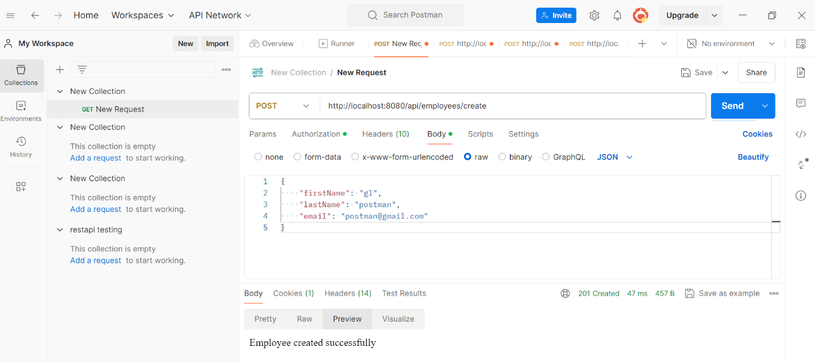

* After clicking on send you will get Employee created successfully msg in response body of postman as above which you can verify form db the created employee and also for UI as below.

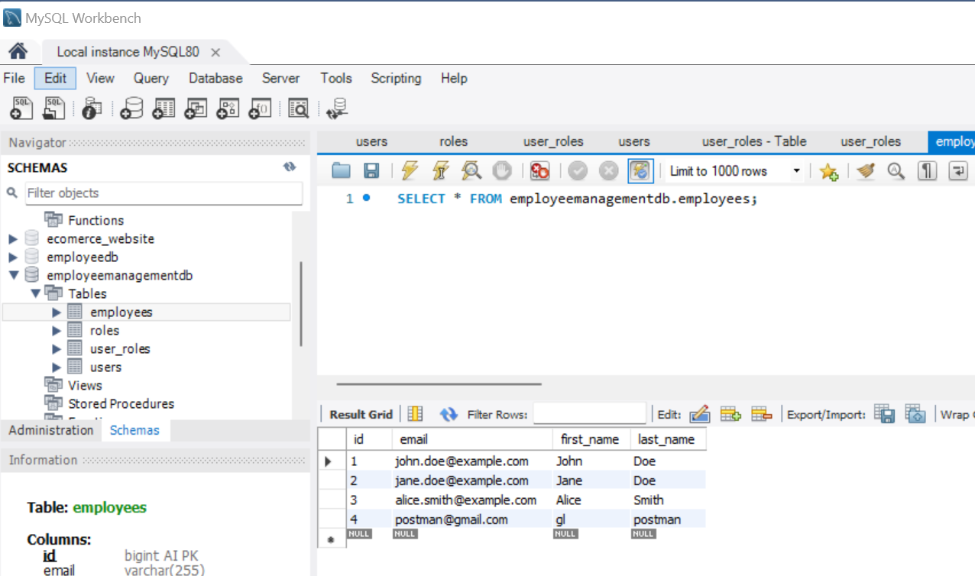

* Employee can also be created from UI as below click on show employee as below

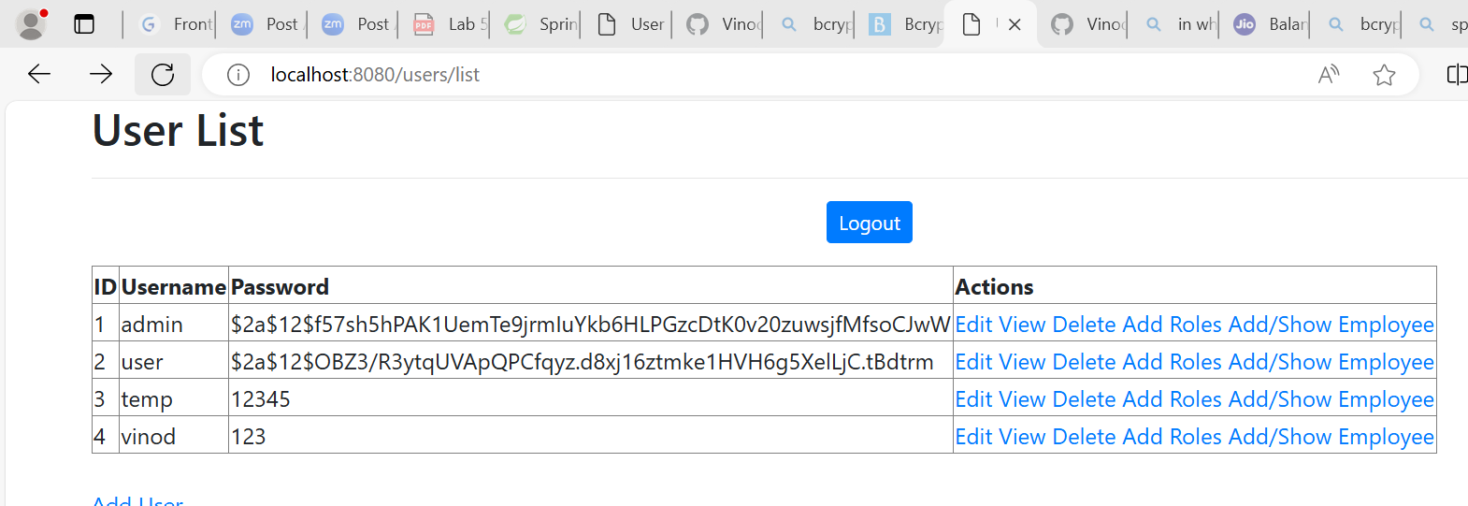

* It will direct you to employee list as below the click on add employee button as below

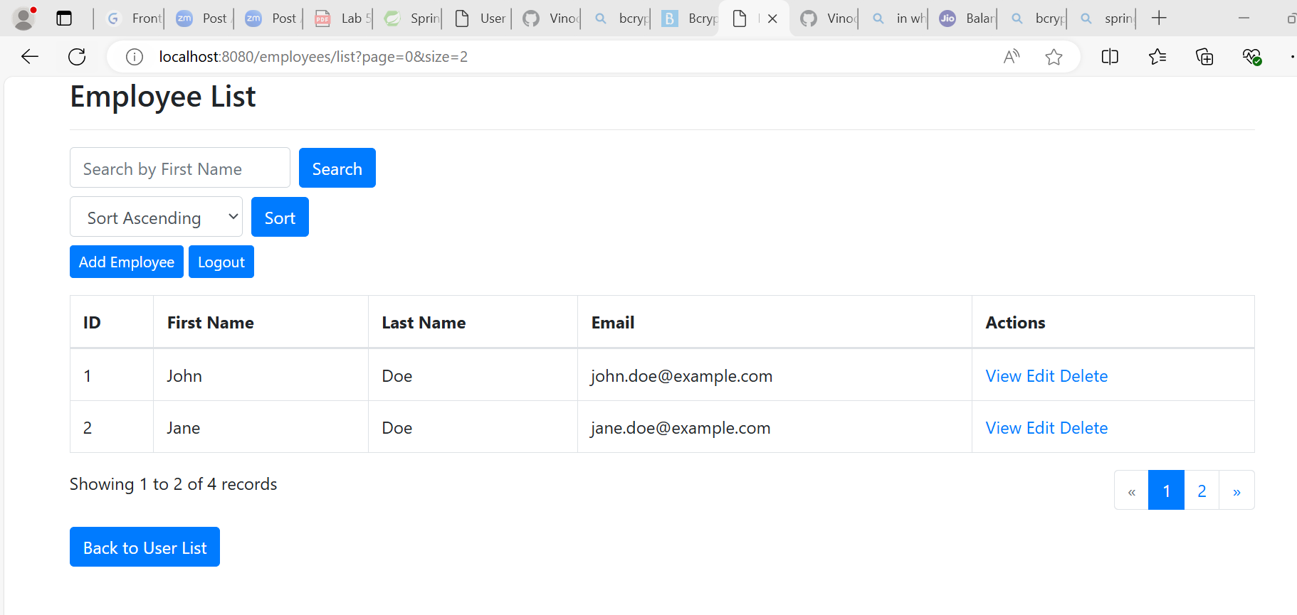

* It will direct you to addemployeeform where fill the details below and click on submit button as below to add employee and same can be verify from ui as well as db.

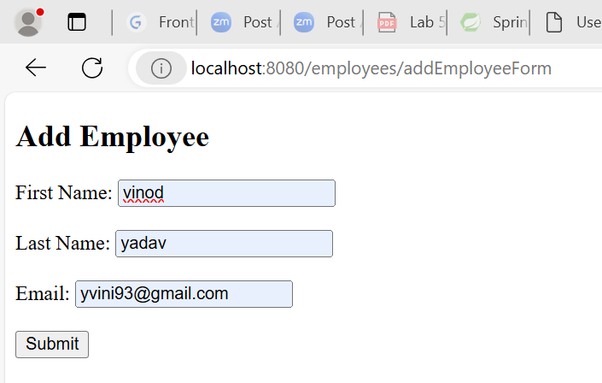

Question-4. application should provide an endpoint to list all the employees stored in the database.

* Do the above step for login as admin in postman if not login then select method as get and type url- <http://localhost:8080/api/employees/list> (method is available in RestEmployeeControlle) in postman and click send it will list the all employee in response body as below

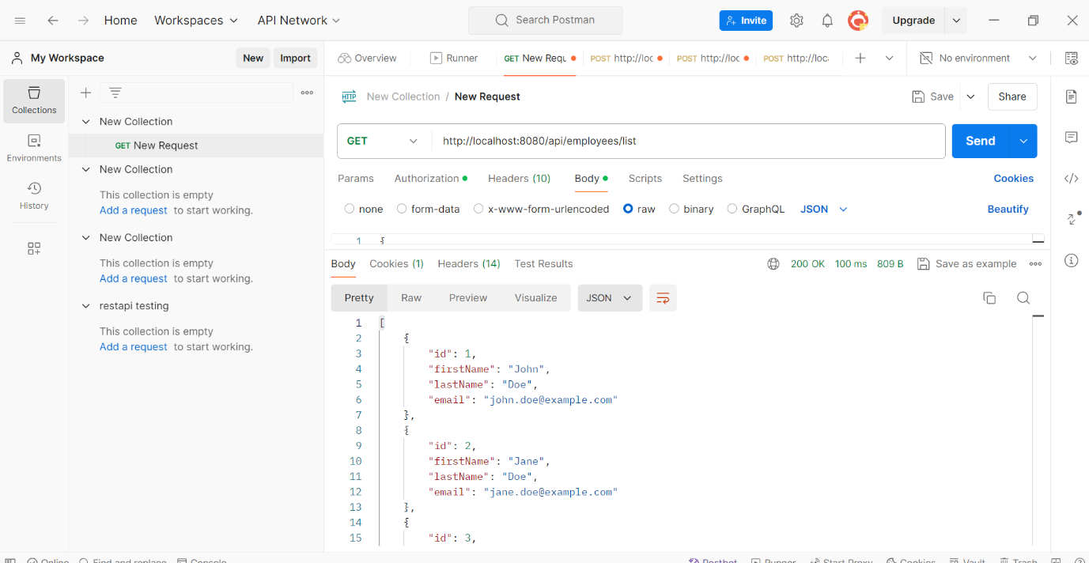

* All employee can be view from browser in ui by clicking on add/show employee in action column of userlist as below



* It will direct to employee list to view all employee in database as below



Question-5. application should provide endpoint to fetch or get an employee record specifically based on the id of that employee-

* Do the above step for login as admin in postman if not login then select method as get and type url- http://localhost:8080/api/employees/3 (method is available in RestEmployeeControlle) in postman and click send it will list the employee with id 3 in response body as below

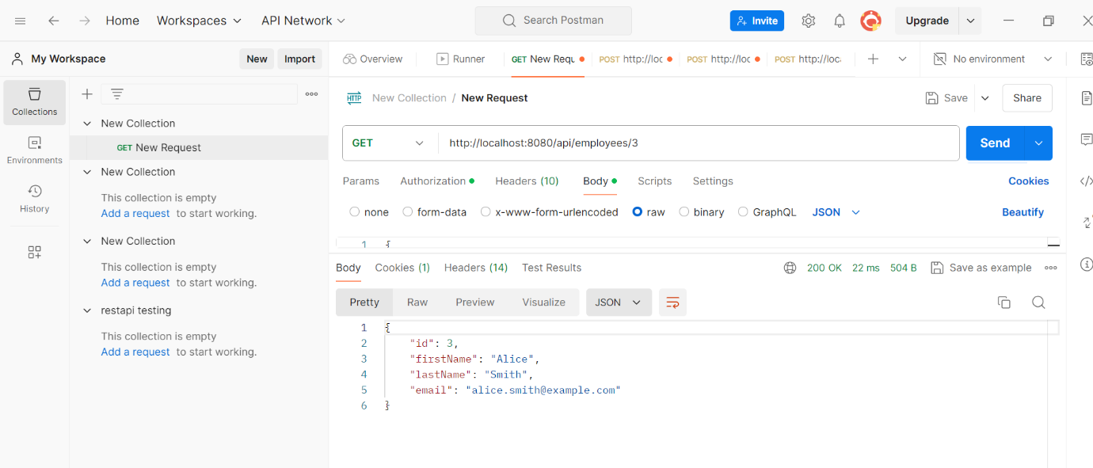

* Same thing can be done form UI in browser in employee list by selecting view in action column of employee list as below.



* It will direct to employee details page as below for specific id here in this case is 1.

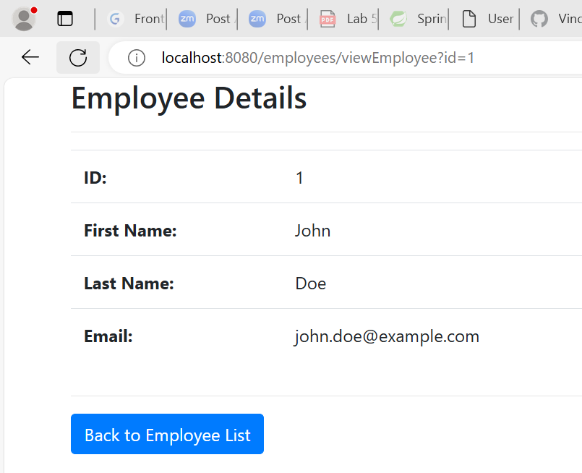

Question-6. application should provide an endpoint to update an existing employee record with the given updated json object.

* Do the above step for login as admin in postman if not login then select method as PUT and type url- http://localhost:8080/api/employees/1 (method is available in RestEmployeeControlle) in postman then type json object in request body as below and click send it will update the record of employee with id 1 and updated record we will get in response body as below

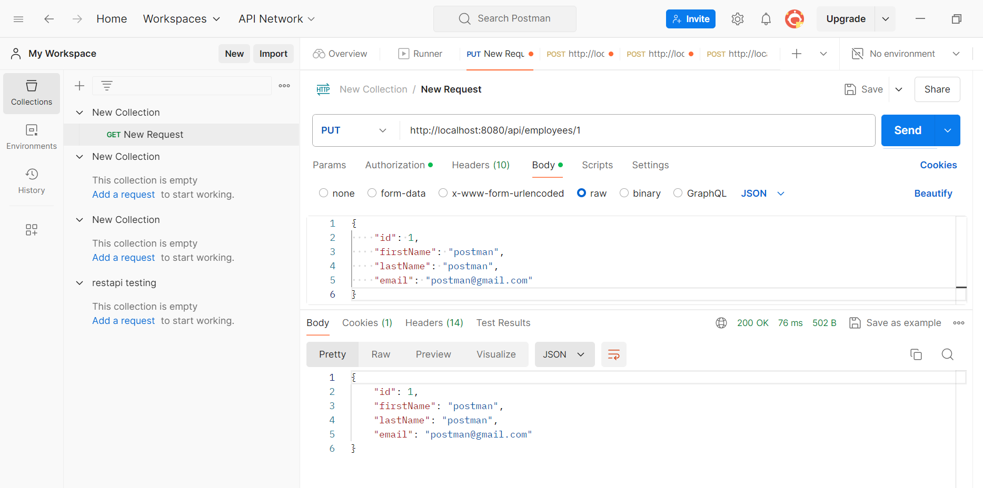

* We can verify the updated change in db as well as in ui employee list as below

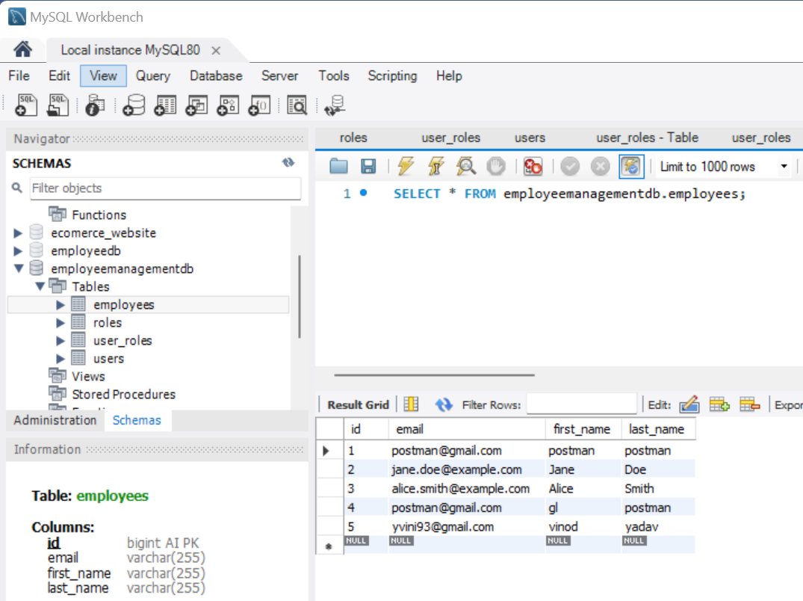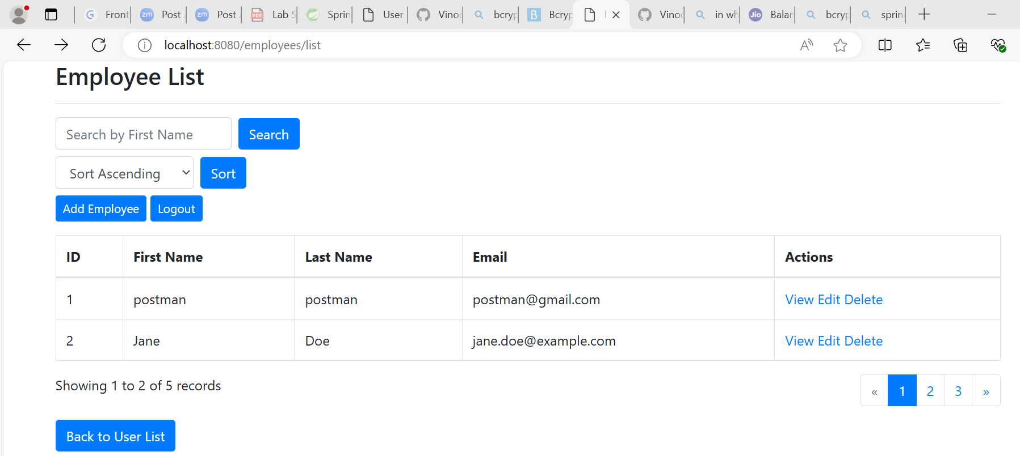

* Same thing can be done through ui in employee list select edit as below



* It will direct to editemployeeform with id as shown below for update do the changes same will be reflected in db as well as employee list ui.

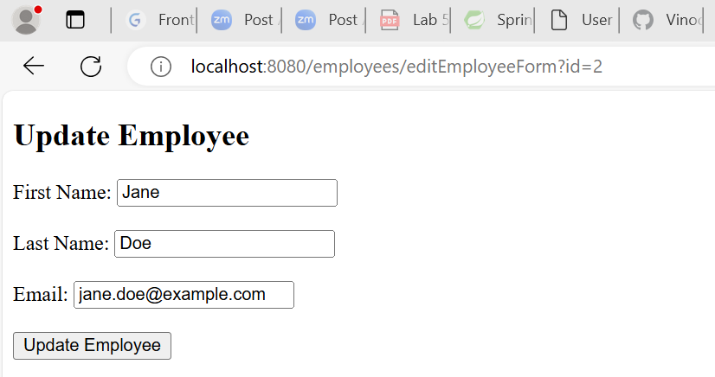

Question-7. application should also provide an endpoint to delete an existing employee record based on the id of the employee-

* Do the above step for login as admin in postman if not login then select method as DELETE and type url- http://localhost:8080/api/employees/1 (method is available in RestEmployeeControlle) in postman and click send it will DELETE the record of employee with id 1 and Deleted employee id – 1 will get in response body as below

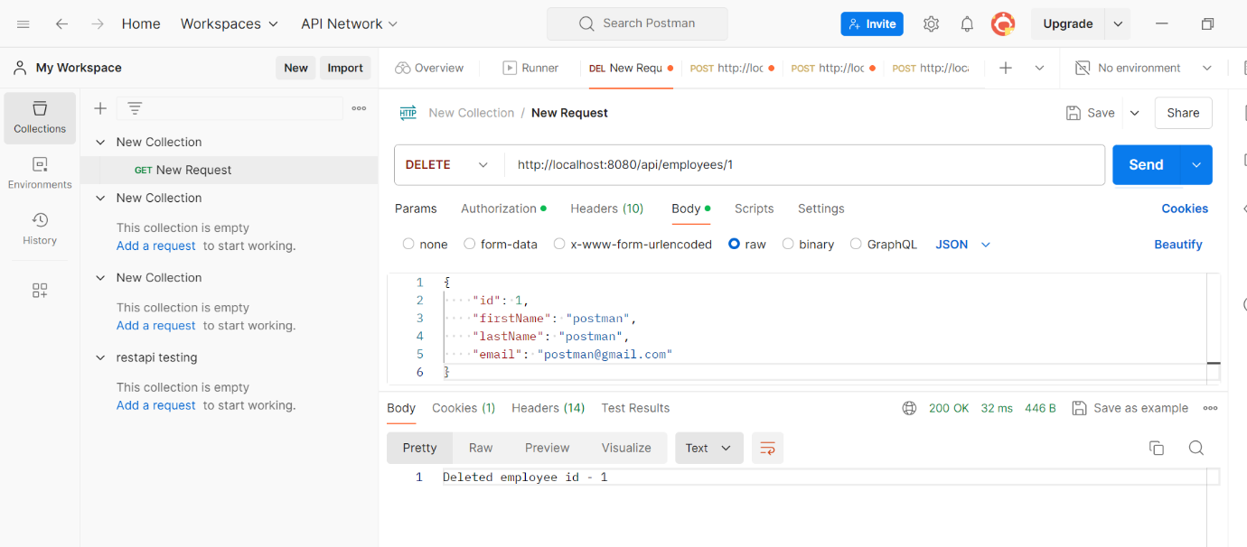

* We can verify the deleted record in db as well as in browser as below.

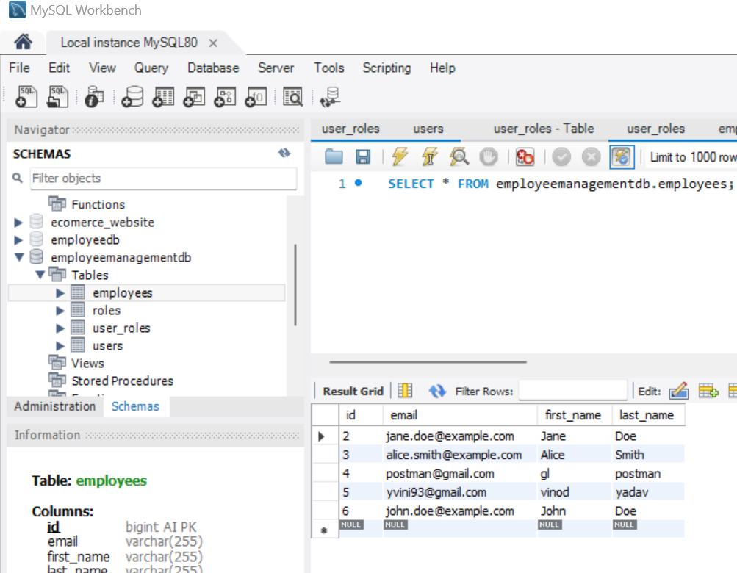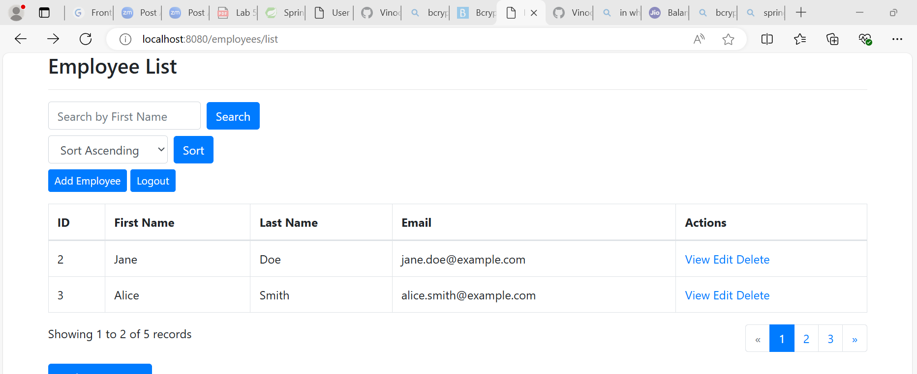

* Employee detail can also be deleted from ui by clicking on delete in action column of employeelist as below



Question-8. application should provide an endpoint to fetch an employee by his/her first name and if found more than one record then list them all-

* Do the above step for login as admin in postman if not login then select method as GET and type url- http://localhost:8080/api/employees/search/vinod (method is available in RestEmployeeControlle) in postman and click send it will fetch the record of employee with first name as vinod from db table of employee and will get the details of vinod response body as below

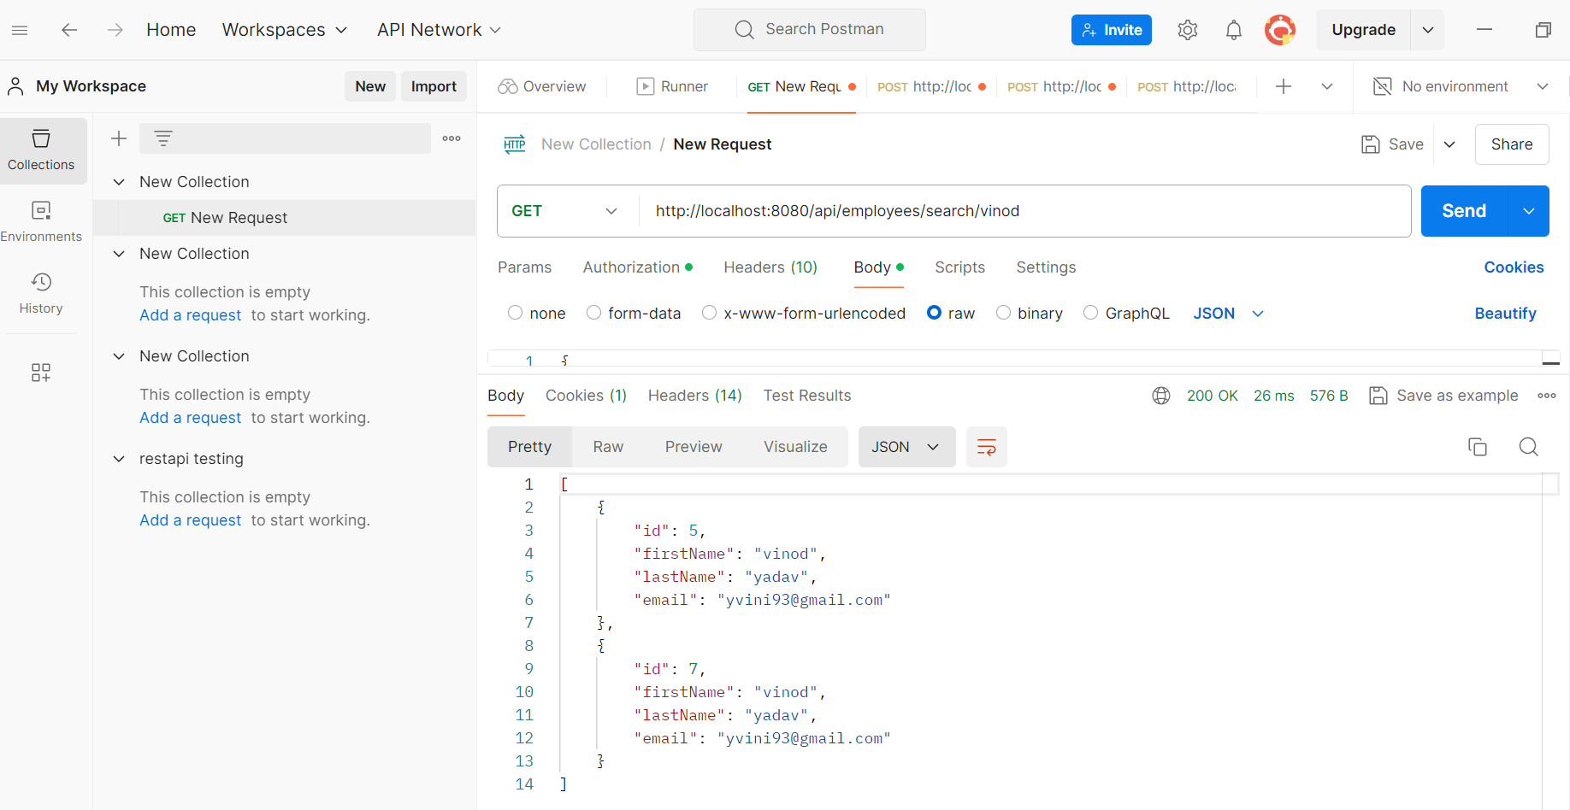

* Same thing can be done from ui of employee list in search bar type first name and click of search button it will fetch the record for typed name from employee table as below

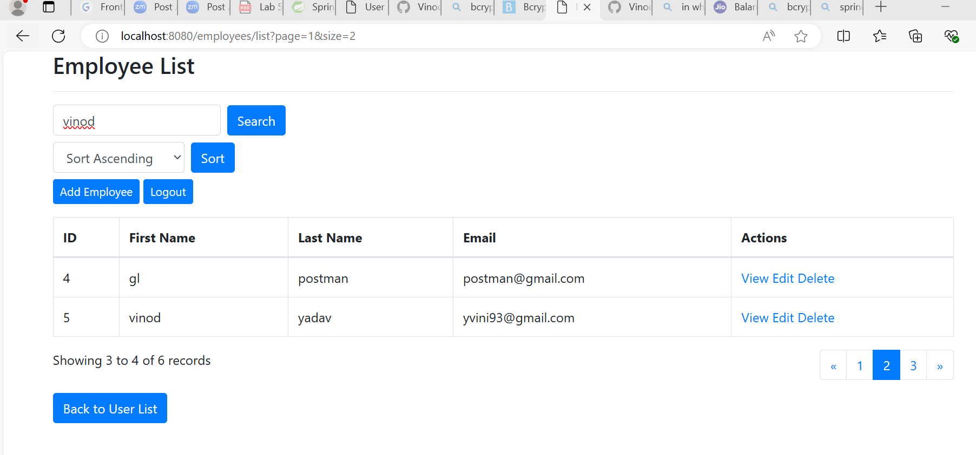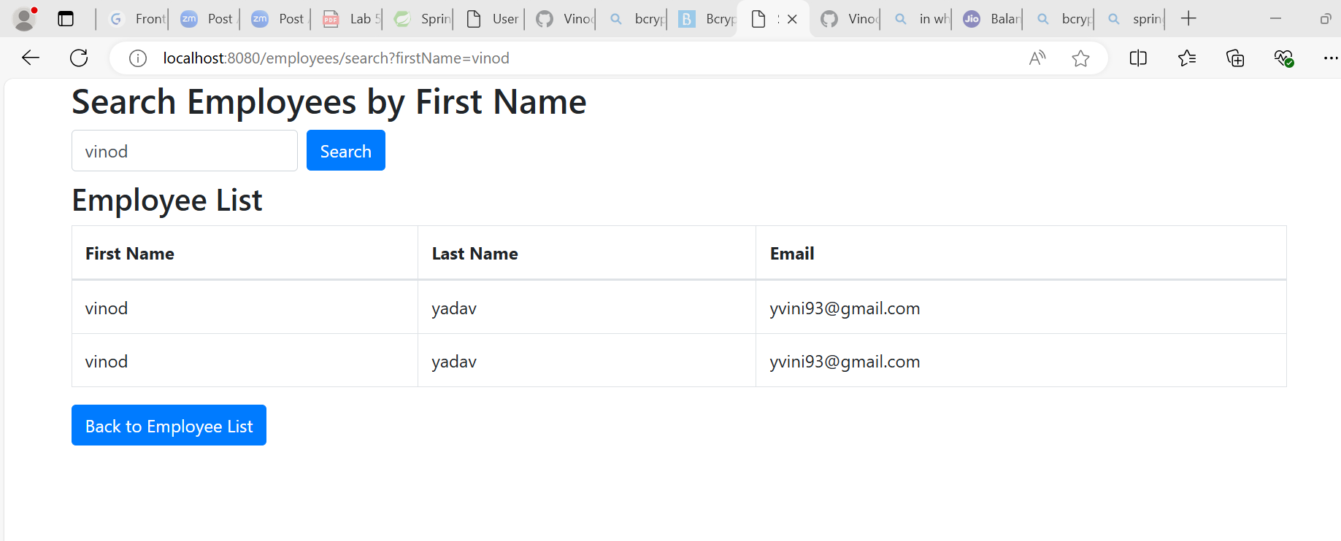

Question-9. application should be able to list all employee records sorted on their first name in either ascending order or descending order .

* Do the above step for login as admin in postman if not login then select method as GET and type url- <http://localhost:8080/api/employees/sort?order=desc> for descending order sorting or <http://localhost:8080/api/employees/sort?order=asc> for ascending order sorting (method is available in RestEmployeeControlle) in postman and click send it will sort the data and give it in response body as below for ascending and descending order.

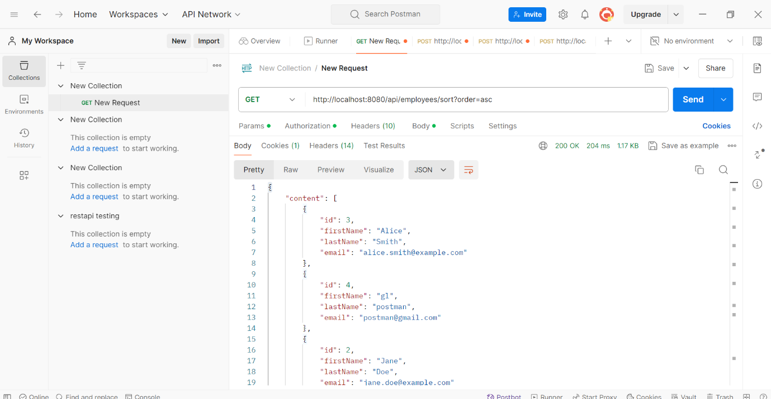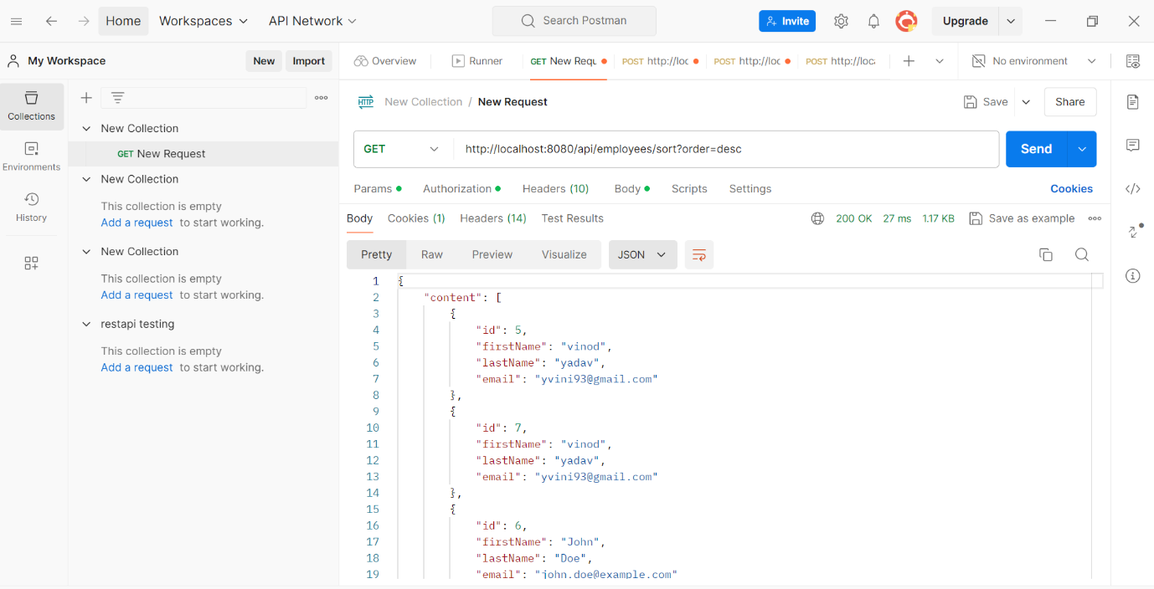

* Same thing can be done from employe list by selecting sorting type from dropdown list below and click on sort button as shown below

